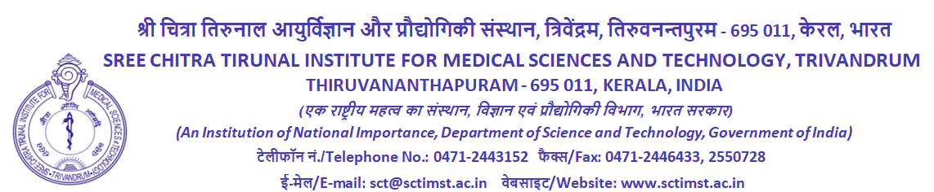
FORM 3
E-Code:
Common Nomination Form for Gratuity, General Provident Fund and Central Government Employees’ Group Insurance Scheme
[See Rule 46 of Central Civil Services (Pension) Rules, 2021, Rule 5 of General Provident Fund (Central Services) Rules, 1960 and Para 19.7 of Central Government Employees’ Group Insurance Scheme, 1980]

I, ..........................................................................................., hereby nominate the person/persons mentioned below and confer on him/her/them the right to receive in the event of my death, to the extent specified below, amount on account of the following:
- any gratuity the payment of which may be authorised under rule 44 and Rule 45 of CCS (Pension) Rules
- amount that may stand to my credit in the General Provident Fund
- any amount that may be sanctioned by the Central Government under the Central Government Employees Group Insurance Scheme , 1980

Name, date of birth (DOB) and address of the nominee | Relationship with employee/ pensioner | Share to be paid to each | If nominee is minor, name, DOB and address of person who may receive the amount on behalf of minor | Name, DOB, relationship and address of alternate nominee in case the nominee under Column (1) predeceases the employee | Share to be paid to each | Name, DOB and address of person who may receive the amount if alternate nominee in Col. (5) is a minor | Contingency on happening of which nomination shall become invalid
1 | 2 | 3 | 4 | 5 | 6 | 7 | 8

These nominations supersede any nominations made by me earlier.

Place and date: Signature of Government servant
Mobile No.

Note 1 : Completely strike out the benefits for which nomination is not intended to be made. Separate copies of this nomination Form may be used for nominating different persons for benefits (i), (ii) and (iii) above

Note 2 : The Government servant shall draw lines across the blank space below the last entry to prevent the insertion of any name after he/she has signed.

Note 3 : The nominee(s)/alternate nominee(s)’ shares together should cover the whole amount.

(To be filled in by the Head of Office/authorised Gazetted Officer)

Received the nominations, dated …………., under the following Rules :—

1. Central Civil Services (Pension) Rules, 2021 for Gratuity
2. General Provident Fund (Central Services) Rules, 1960
3. Central Government Employees Group Insurance Scheme, 1980

made by Shri/Smt./Kumari.....................................

Designation..........................................

Office..........................................

(Strike out which nomination is not received)

Verified that the nomination(s) made by the Government servant is/are in accordance with the provisions of the relevant rules. Entry of receipt of nomination(s) has been made in page …………Volume……….of Service Book.

Name, Signature and Designation of Head of Office/authorised Gazetted Officer with seal

Date of receipt.........................................

The receiving officer will fill the above information and return a duly signed copy of the complete Form to the Government servant who should keep it in safe custody so that it may come into the possession of the beneficiaries in the event of his/her death.

The receiving officer shall put his/her dated signature on both pages of this Form.

